Setup for Lab 3 in Ubuntu
In Lab 3, we will use the GTK+3.0 and cairo framework for drawing images. In order to complete this lab, you should have two separate projects – Client and Server. The Client application will only include your wrappers and use a command line interface and can therefore be installed using your normal procedure.
The Server application however needs additional configuring before we can use it.
You need to install the following packages:
sudo apt-get install build-essential gnome-devel
sudo apt-get install libgtk-3-dev
sudo apt-get install libcairo2-dev
Once completed, you can use the pkg-config tool to find which library paths you need to make GTK work. Firstly, lets start with the library paths:
pkg-config --cflags gtk+-3.0
The output you get will be the library search paths that you will need to include to make the application work. Your output should be something in style with the output I get:
-pthread -I/usr/include/gtk-3.0 -I/usr/include/at-spi2-atk/2.0 -I/usr/include/at-spi-2.0 -I/usr/include/dbus-1.0 -I/usr/lib/x86_64-linux-gnu/dbus-1.0/include -I/usr/include/gtk-3.0 - I/usr/include/gio-unix-2.0/ -I/usr/include/cairo -I/usr/include/pango-1.0 -I/usr/include/harfbuzz -I/usr/include/pango-1.0 -I/usr/include/atk-1.0 -I/usr/include/cairo -I/ usr/include/pixman-1 -I/usr/include/freetype2 -I/usr/include/libpng16 -I/usr/include/freetype2 -I/usr/include/libpng16 -I/usr/include/gdk-pixbuf-2.0 -I/usr/include/libpng16 -I/usr/include/glib-2.0 -I/usr/lib/x86_64-linux-gnu/glib-2.0/include
Now this is a quite annoying process to add to your eclipse environment (and I apologize for that), so what you now need to do is go to the project properties of your eclipse environment. See pic:
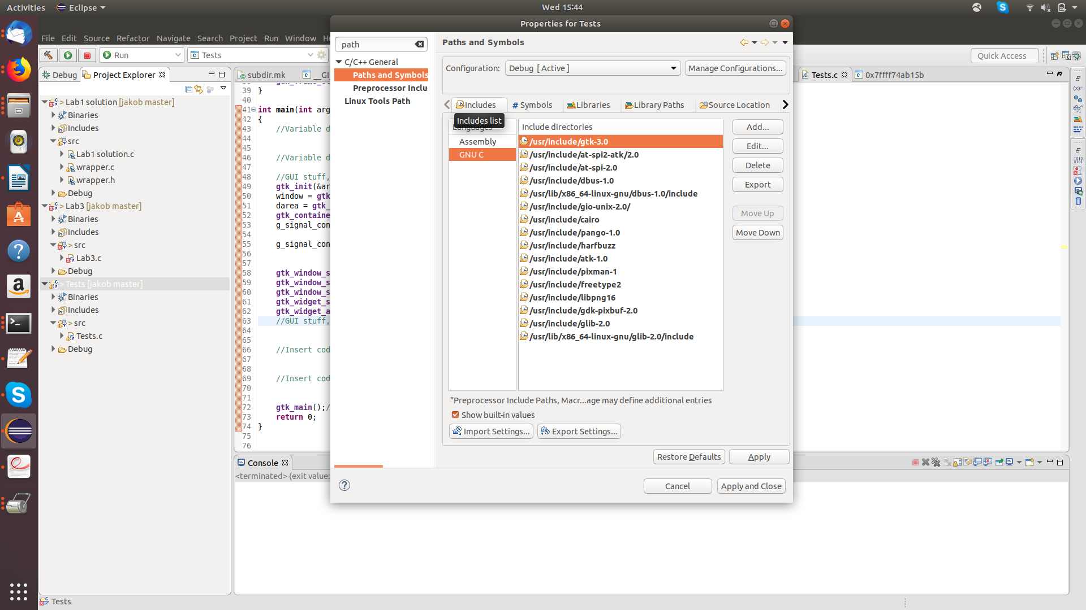
As you also can see, I already added all library paths needed in the environment. So you should do the similar for all library paths given by your pkg-config output.
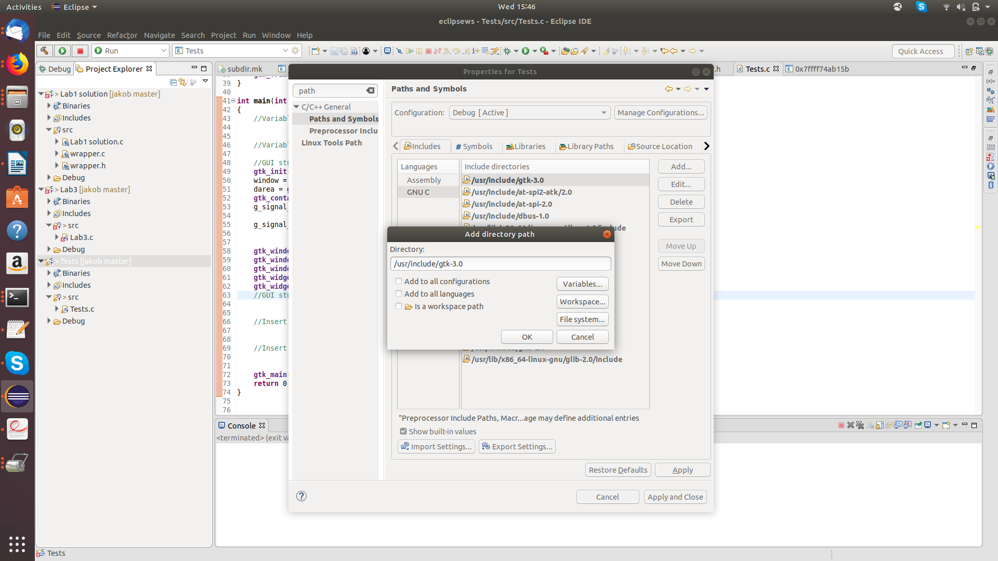
In the second, you need to add additional libraries to your project. You do this in the same way with pthreads and message queues.
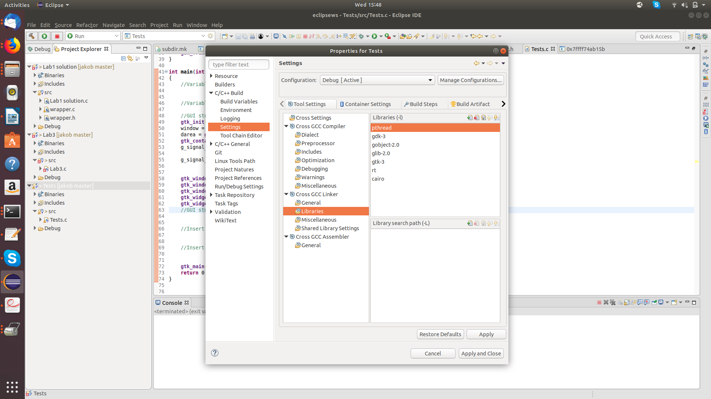

I found that the extra libraries needed for this application to run were:
- gdk-3
- gobject-2.0
- glib-2.0
- gtk-3
- cairo
In case you run in to other issues, you can once again run the pkg-config tool to check which libraries gtk has dependencies to:
pkg-config --libs gtk+-3.0
Which will give you an output similar to:
-lgtk-3 -lgdk-3 -lpangocairo-1.0 -lpango-1.0 -latk-1.0 -lcairo-gobject -lcairo -lgdk_pixbuf- 2.0 -lgio-2.0 -lgobject-2.0 -lglib-2.0
I do suspect that some might run in to issues while compiling this, so do not hesitate to contact me jakob.danielsson@mdh.se if something becomes messy in the installation procedure or if anything is unclear.

